Hw9 11612126 Keming Li Intelligent Robotic

## Problem 1

**Gauss probability result**

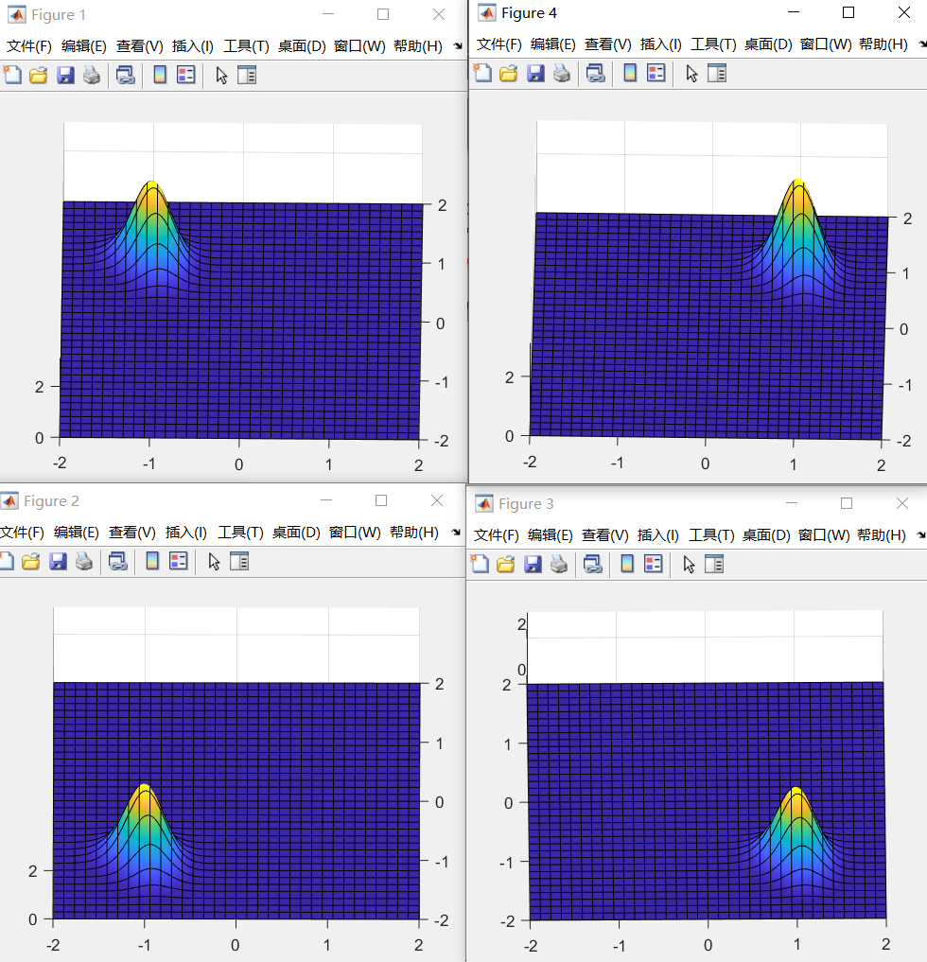

**explanations**

**To find a**

range1=max([abs(r1-r2),

abs(r2-r3),

abs(r3-r4),

abs(r4-r1)]); %c>a+b

range2=min([abs(r1+r2),

abs(r2+r3),

abs(r3+r4),

abs(r4+r1)]);%c<a+b

a0=rand () * (range2-range1) + range1;

a=fsolve(@F, a0);

take left lower landmark as example, assume the position of robot is Q

in order to calculate $p\left(x_{0}=x , y_{0}=y\right)$

the left upper landmark pose(1) should be $(x, y+a)$

the right lower landmark pose(3) should be $(x+a, y)$

the right upper landmark pose(4) should be $(x+a, y+a)$

$$p\left(x_{0}=x , y_{0}=y\right)=\prod_{i}{ G\left( dist\left(pose\left(i\right), Q\right)-r_{i} \right| μ=0, σ=σ_{i} )}$$

## problem 2

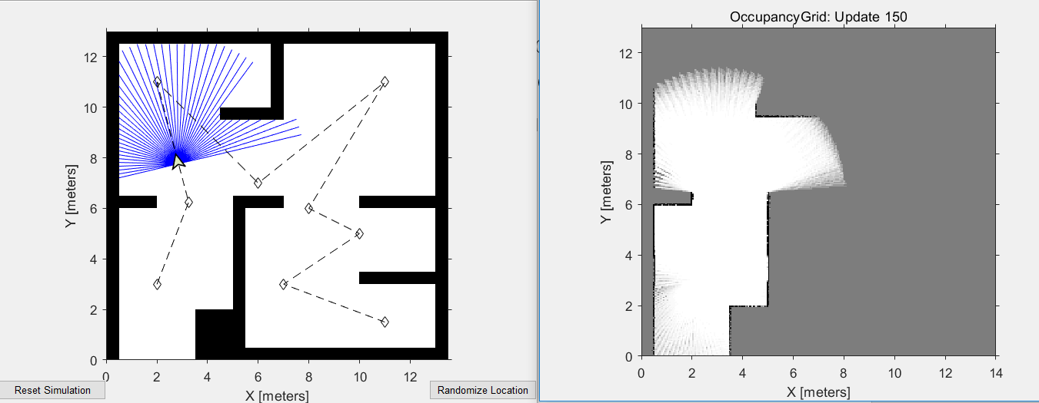

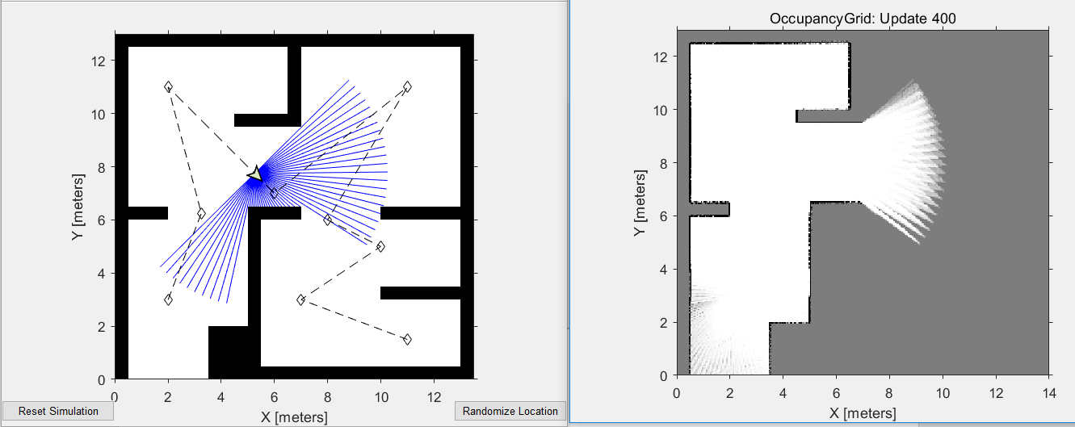

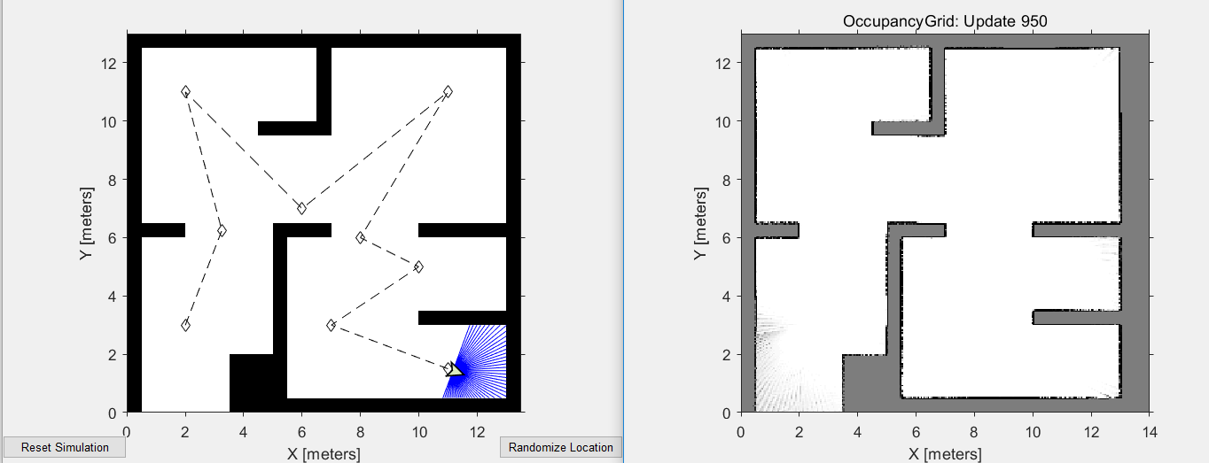

## problem 3

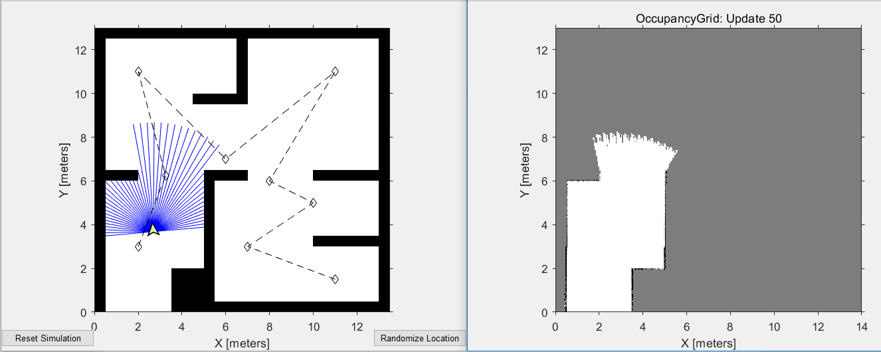

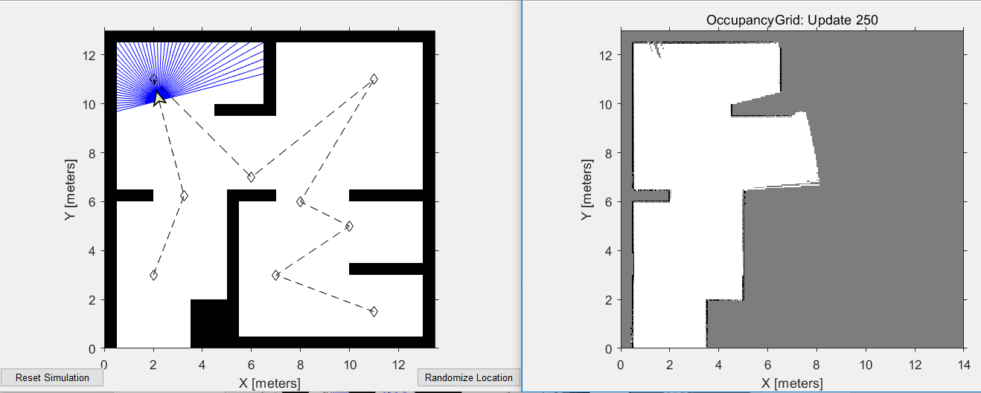

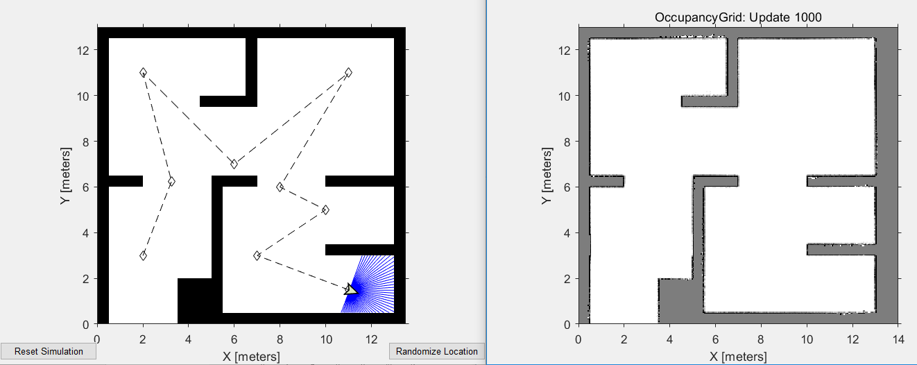

## Problem 4

For the left lower single landmark, A

$$p\left(x_{0}=x , y_{0}=y\right)=G\left( dist_{A}-r_{A} \right| μ=0, σ=σ_{A_dist} )×G\left( Δθ_{A} \right| μ=0, σ=σ_{A_theta} )$$

$$where dist_{A} means distance between landmark A and robot position Q,$$

$$Δθ=atan2\left(y-y_{Q}, x-x_{Q}\right)-atan2\left(y_{A}-y_{Q}, x_{A}-x_{Q}\right)= atan2\left(y-y_{Q}, x-x_{Q}\right)-θ_{2}$$

Other landmarks are the same idea

**Results is shown as below:**

